CN LAB 7

24K-0810
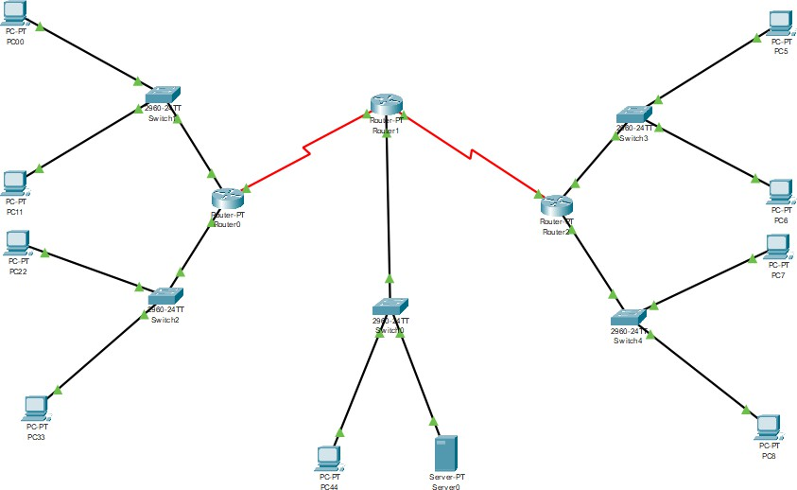

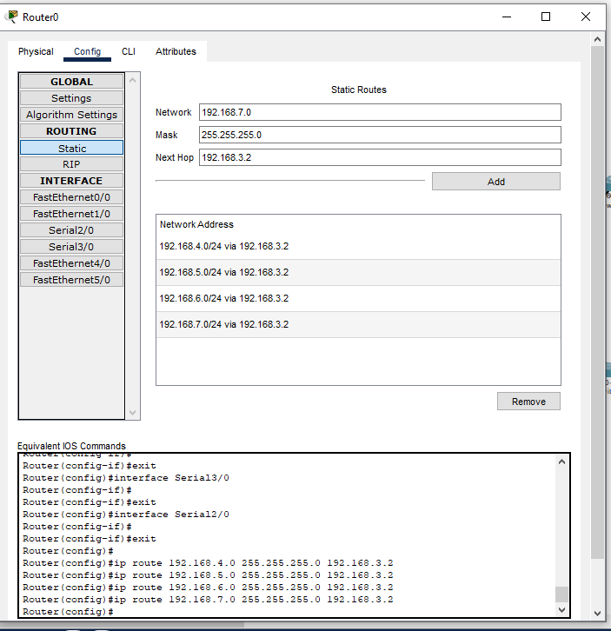

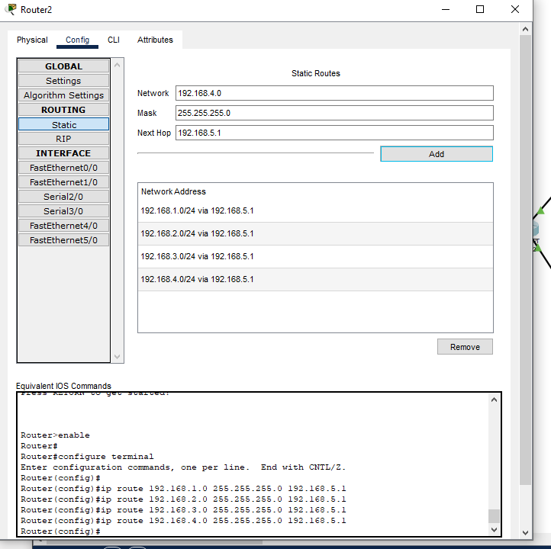

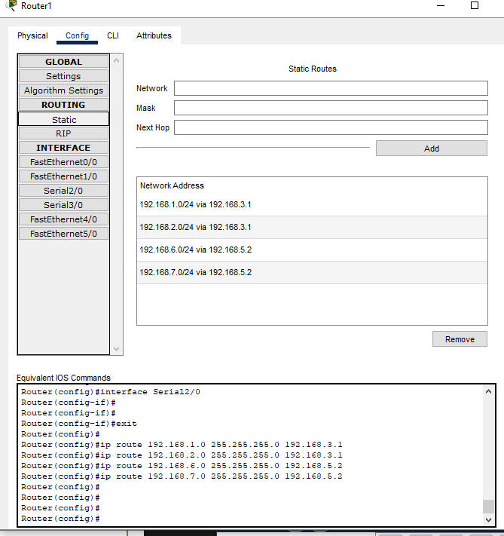

Task 1:

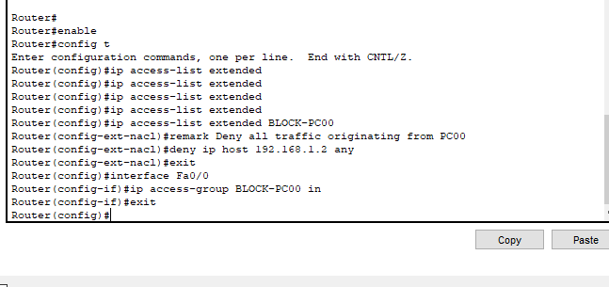

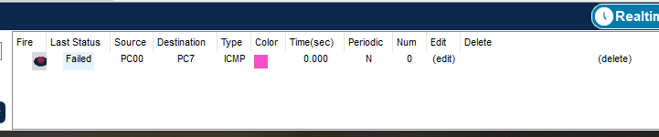

Task 2:
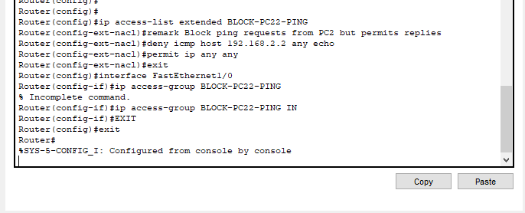

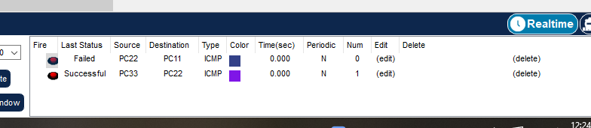

Task 3:
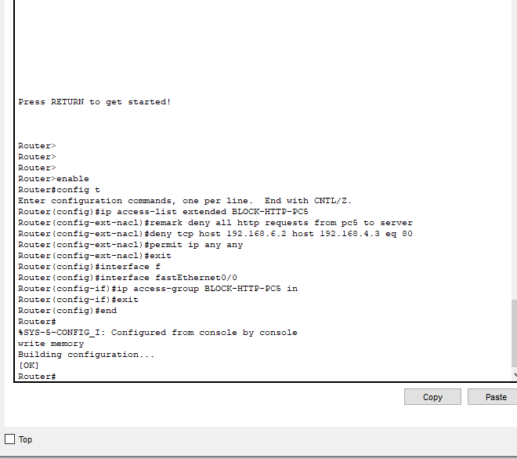

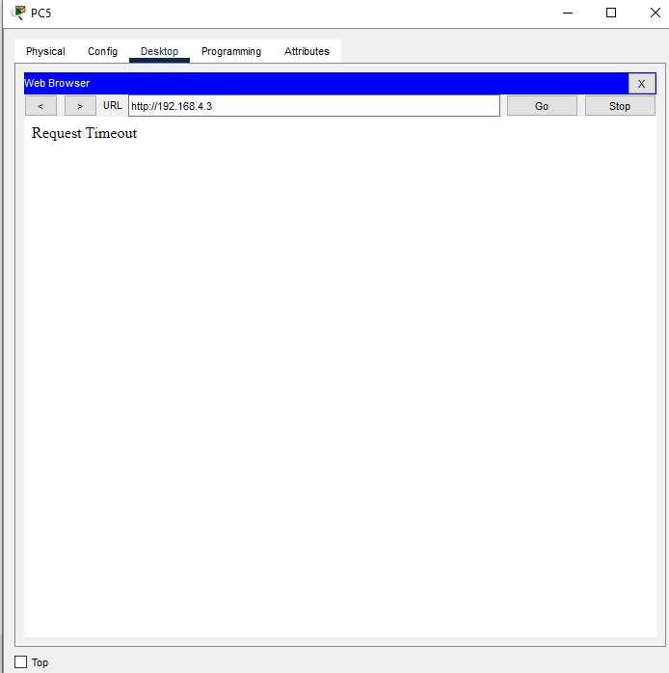

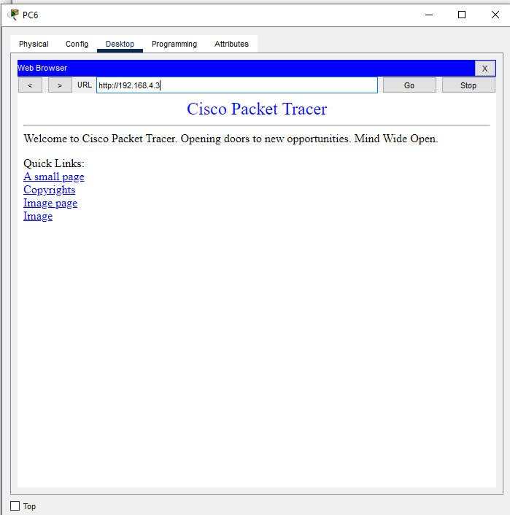

Task 4:

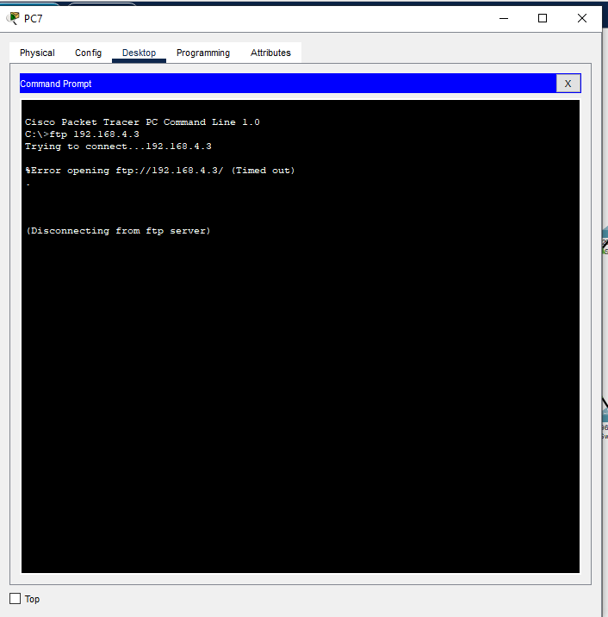

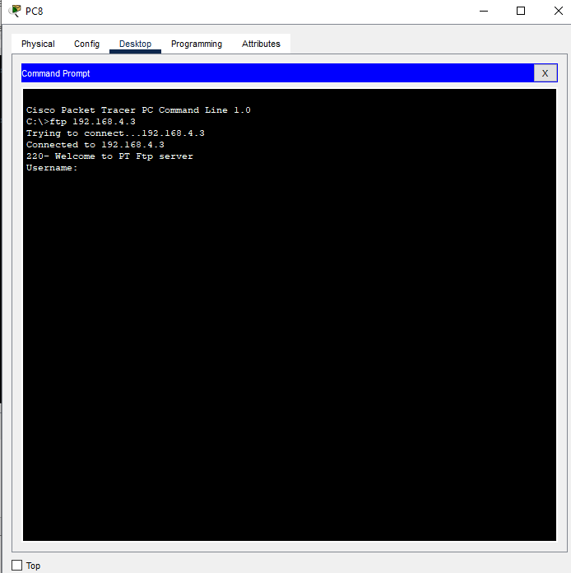

Task 5:

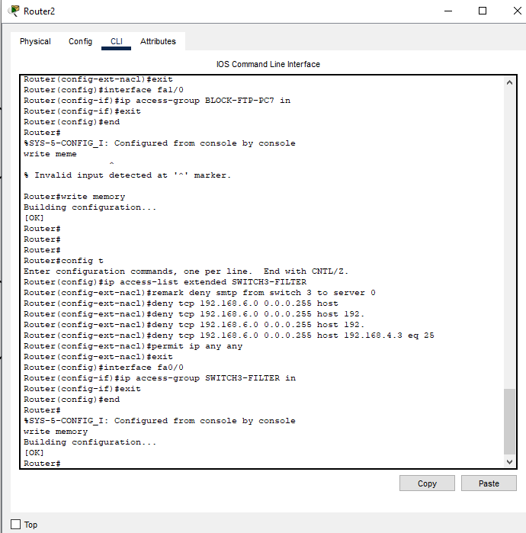

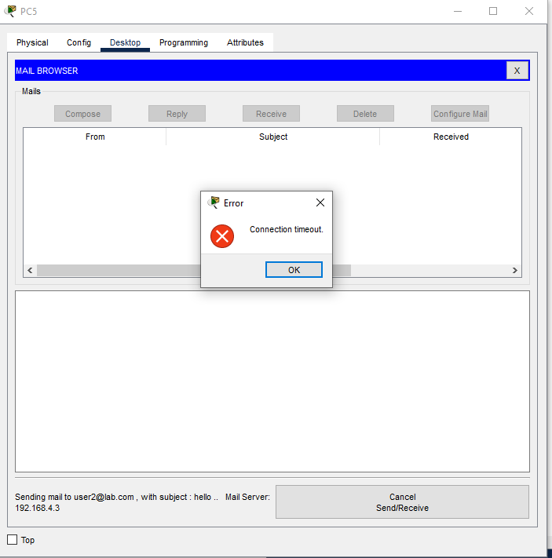

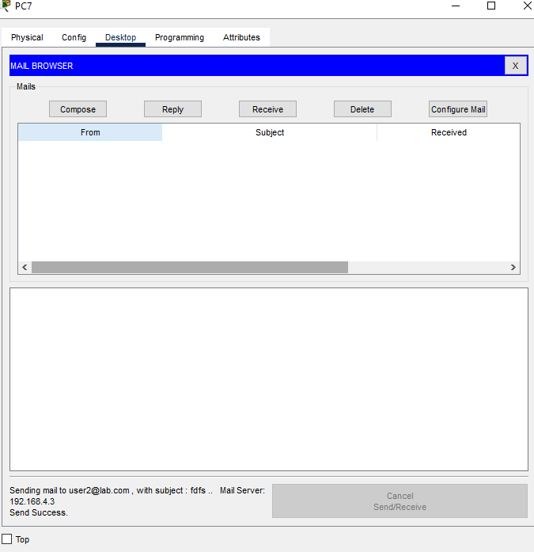

Task 6:

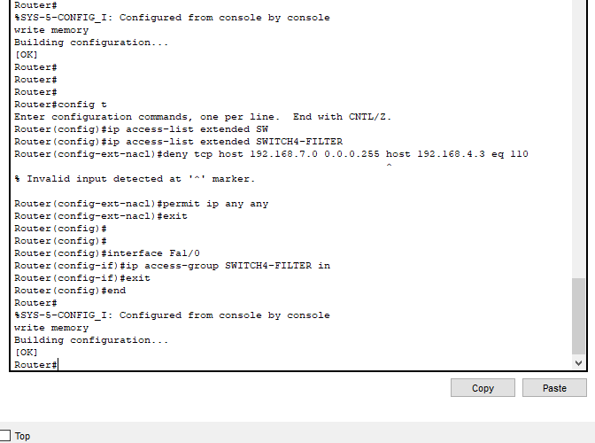

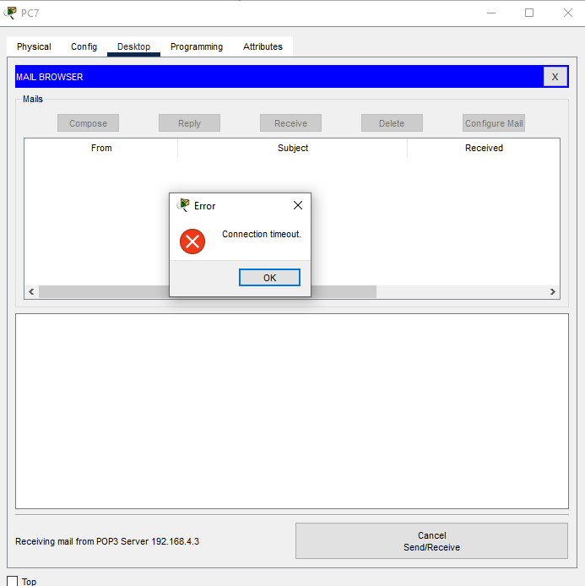

Task 7:

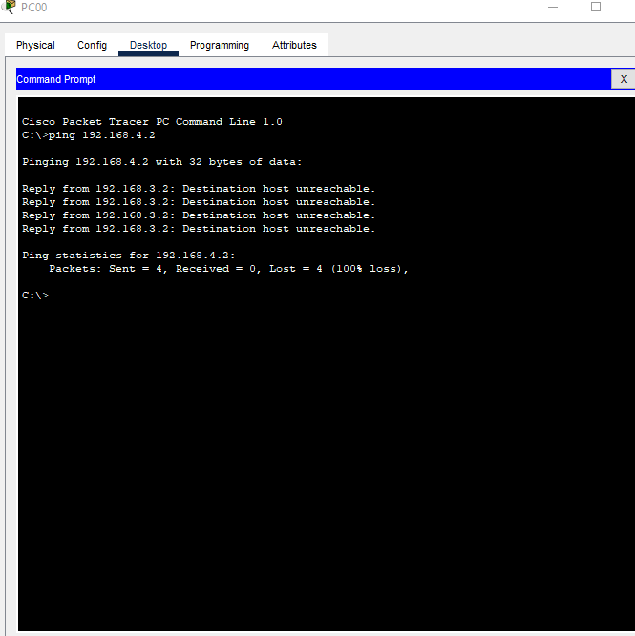

Task 8:
To document the applied network security policies, extended Access Control Lists (ACLs) were configured across all three routers to filter specific traffic. On
**Router0**, the `BLOCK-PC0` ACL is applied inbound on interface `Fa0/0` with the rule `deny ip host 192.168.1.2 any`, while `BLOCK-PC2-PING` is applied

inbound on `Fa1/0` with `deny icmp host 192.168.2.2 any echo`. On **Router1**,
`BLOCK-PING-PC4` is applied outbound on `Fa0/0` using `deny icmp any host 192.168.4.2 echo`. On **Router2**, interface `Fa0/0` uses the inbound
`SWITCH3-FILTER` ACL containing `deny tcp host 192.168.6.2 host 192.168.4.3 eq 80` (HTTP) and `deny tcp 192.168.6.0 0.0.0.255 host 192.168.4.3 eq 25` (SMTP),
while interface `Fa1/0` uses the inbound `SWITCH4-FILTER` ACL containing `deny tcp host 192.168.7.2 host 192.168.4.3 eq 21` (FTP) and `deny tcp 192.168.7.0
0.0.0.255 host 192.168.4.3 eq 110` (POP3). Every ACL concludes with the rule
`permit ip any any` to ensure unblocked network traffic passes through successfully.

Task 9:
The order of rules in an Access Control List (ACL) is critical because packets are evaluated sequentially from top to bottom. As soon as a packet matches a rule's condition, the defined action (`permit` or `deny`) is executed immediately, and no further rules are evaluated. Consequently, specific `deny` rules must always be placed above broader `permit` rules; placing a general rule like `permit ip any any` at the top causes all subsequent `deny` statements to be completely bypassed and ignored. Furthermore, any traffic that does not match any explicit rule down the list is automatically dropped by the implicit deny statement at the end of the ACL.

Task 10:
The order of rules matters in an Access Control List (ACL) because traffic is evaluated sequentially from top to bottom. Once a packet matches a rule, the designated action (`permit` or `deny`) is executed immediately, and evaluation stops without checking any subsequent rules. Because of this first-match behavior, specific `deny` statements must always be placed above broader `permit` statements; placing a general rule like `permit ip any any` at the top causes all

lower `deny` rules to be bypassed. Additionally, any packet that fails to match an explicit rule is automatically dropped by the implicit deny statement at the end of the ACL.

